**Mobile Price Prediction**

**Problem Statement:**

Understand the problem: Mobile prices reflect consumer preferences and are crucial for both buyers and sellers.

Identify the features that impact prices (e.g., RAM, battery power, screen resolution).

**Data acquisition and Pre-processing:**

Imported data from project are brief.



Clean and pre-process the data (handle missing values, outliers, etc.).

Missing values

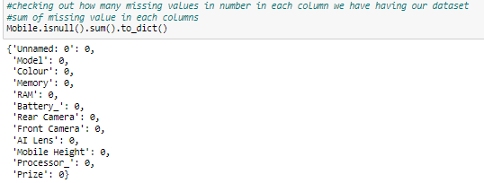

Outliers

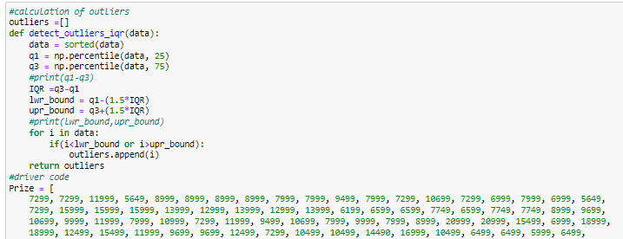

Visualization of outliers

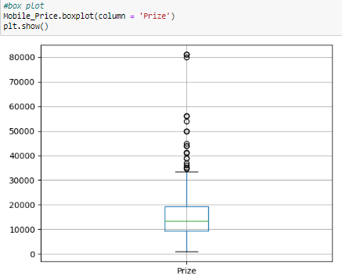

**Exploratory Data Analysis (EDA):** Conduct EDA to understand the distribution and relationships of different features with the target variable (price). Look for correlations and patterns in the data.

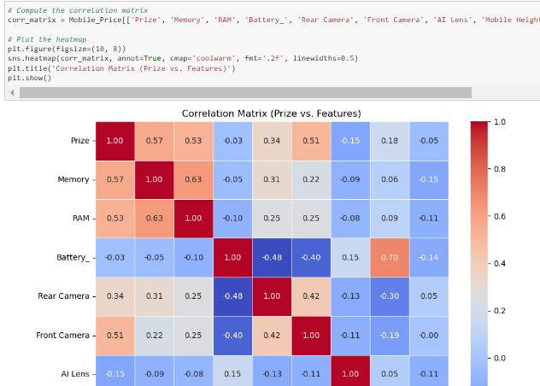

Identify important features (e.g., RAM, battery power, screen dimensions).



**Feature Selection:**

Use techniques like correlation analysis or feature importance to select relevant features.

Prioritize features that strongly influence mobile prices.

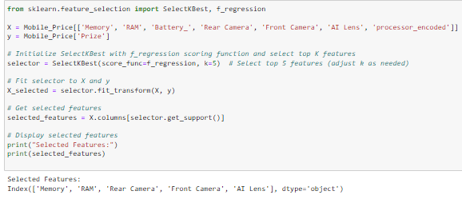

**Model Building:**

Choose appropriate regression techniques (e.g., Random Forest Regression, Linear Regression and Random Forest Regression).

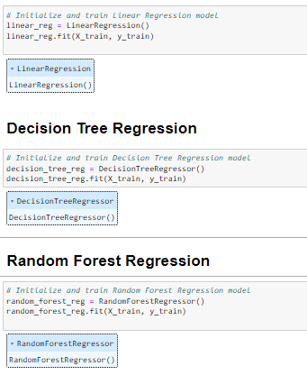

Train the model using relevant features.

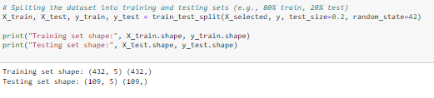

**Model Evaluation:**

Assess model performance using metrics like Mean Absolute Error (MAE) or Root Mean Squared Error (RMSE).

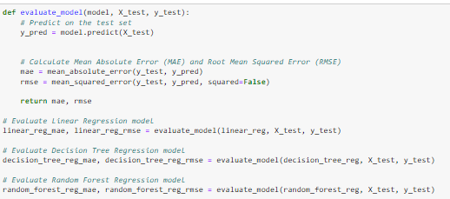

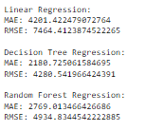

**Regression Models Evaluation**:

Evaluating three regression models: Linear Regression, Decision Tree Regression, and Random Forest Regression.

The evaluation metrics used are Mean Absolute Error (MAE) and Root Mean Squared Error (RMSE).

These metrics help assess the accuracy of the models in predicting continuous numerical values (such as mobile prices).

**Prediction and Interpretation:**

Use the trained model to predict mobile prices.

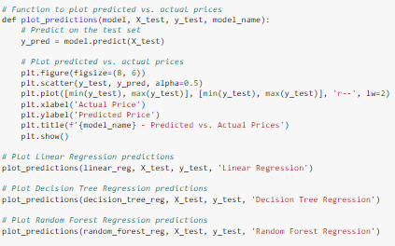

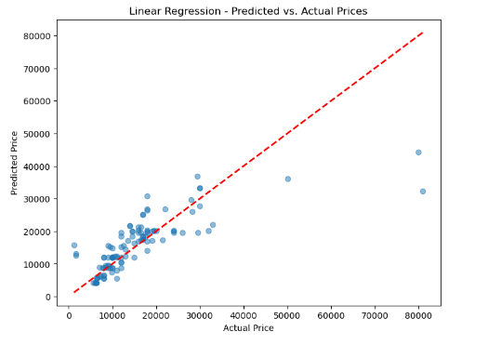

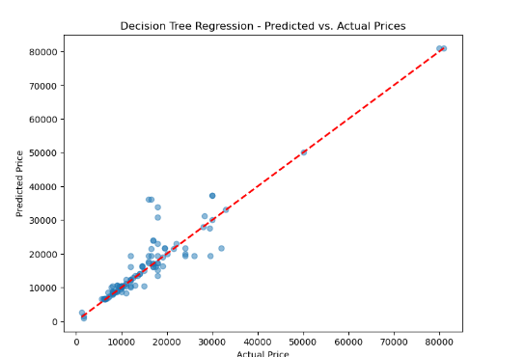

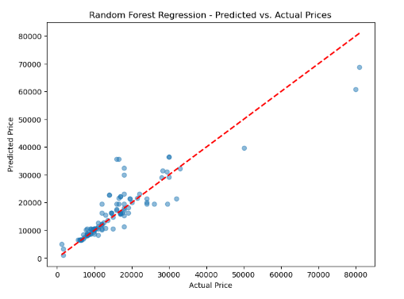

The scatter plot shows individual data points representing actual prices (y-axis) and predicted prices (x-axis) for mobiles.

The diagonal line represents the ideal scenario where predicted prices perfectly match actual prices.

Deviations from the diagonal line indicate the model’s prediction errors.

Clusters of data points around the diagonal line suggest accurate predictions.

Outliers far from the diagonal line indicate significant prediction discrepancies.

**Interpret the results**: Summarize findings, including model accuracy, important features affecting prices, and potential insights for stakeholders (e.g., manufacturers, retailers, consumers)..

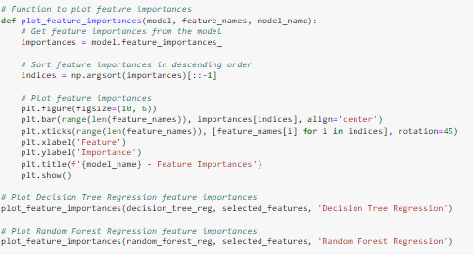

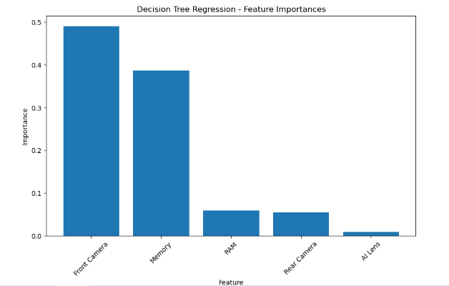

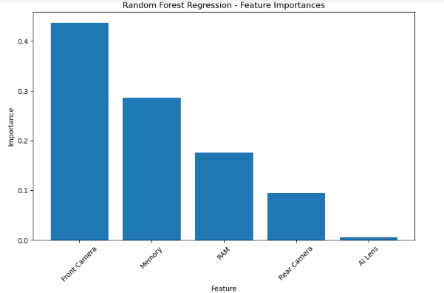

The bar graph shows the relative importance of various features in a decision tree regression model and random forest regression.

Each feature is represented by a vertical bar, and the height of the bar indicates its importance.

Features with taller bars contribute more significantly to the model’s predictions.